Business Plan
ABC Chapter
March 1, 2022

Contributors:
Jennifer Goodenow, IIBA GCC Mentoring Team
Michelle Green, IIBA GCC Mentoring Team

INTRODUCTION 3
GLOSSARY 4
VISION 5
MISSION 5
MANAGEMENT BOARD AND STAFF 5
PRODUCTS AND SERVICES 7
ORGANIZATIONAL GOALS 8
Board Role: Vice President of Education 8
Board Role: Vice President of Marketing 10

INTRODUCTION

Purpose: The Business Plan has been developed by the IIBA Mentoring Team in order to provide Chapters with a disciplined approach to Business Planning. Chapters are free to adjust the template in any way they see fit for their Chapter, region or language. They are also free to use any other template of their own.

Inputs: Chapter’s Strategic Plan, Chapter’s Bylaws, and IIBA Strategic Plan.

Frequency: Generated annually to allow for adjustments or alignment to changing market conditions and new board members. Since the Business Plan provides a foundation for the marketing and financial plans, it should be reviewed prior to those planning sessions.

Participants: The entire Board of Directors and program leads for the Chapter. Each Board role should provide details for their contributions in the Business Plan.

Publication: The Business Plan should be available to all Chapter members in good standing but is typically summarized in Chapter communications with a link to the actual document provided.

Relationships: The Strategic Plan is used as an input to the Annual Business and Financial Plans.
The Business Plan has been developed by the <Chapter name> Chapter in order to provide a disciplined approach to the management of the Chapter over the calendar year. For the <Chapter name> Chapter, the Business Plan will be used to align board members, volunteers and partners with the goals of the organization and commit to the Chapter’s Mission and Goals through specific and measurable objectives. The Financial Plan should be reviewed against the Business Plan prior to committing finances for the fiscal year.

GLOSSARY

Term | Definition
Communication Channels | The different ways the board communicates with the members and why this is important. Describes the primary reason for channels, i.e., event promotions, elections, volunteer recruitment, and anything else that is important to the successful operation of the Chapter.
Essential Business Resources | The tools and services are needed to operate your Chapter. This should include technologies such as QuickBooks or SharePoint, as well as any other relationships with other groups inside or outside of IIBA.
Membership Characteristics | Members/member types, demographics, sponsors and/or corporate affiliations, educational and other institutional memberships, etc.
Revenue Sources | The main sources of revenue and the impact to your operations. This may also reveal areas of risk, and should describe plans to pivot if any of these become challenging.

VISION
The vision for the ABC Chapter is to be the organization of choice for all Business Analysts (BA) in the Greater Fictitious City area for BA certification readiness, mentoring, learning and education, done in ways that create a more sustainable Chapter and better shared future that makes a difference in people’s lives and communities.

MISSION
The mission for the ABC Chapter is to create greater awareness of the BA profession by defining what is business analysis and working towards recognition of the value of the business analyst role. The ABC Chapter is dedicated to bringing to the Fictitious City Business Analyst Community together to help grow, connect, and evolve the profession of Business Analysis.

MANAGEMENT BOARD AND STAFF
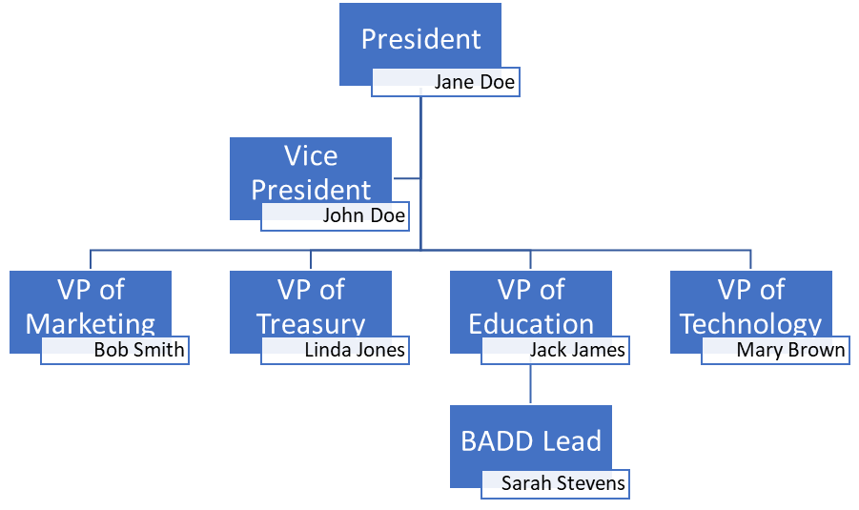
COMMUNICATION CHANNELS
Note: Channel Type may include any of the following common channels or any others that apply to your Chapter:

Website (Main Site) Social Media (Facebook) Email Collaboration (Google)
Website (PDD site) Social Media (Twitter) Newsletter Collaboration (Slack)
Website (Helpdesk) Social Media (LinkedIn) Survey Collaboration (Miro)
Website (other) Social Media (Instagram) Voting/Ballot Collaboration (SharePoint)
Social Media (Tik Tok) Phone Collaboration (Trello)
Social Media (other) Fax Collaboration (Telegram)
Doc Repository Collaboration (Whats App)
Collaboration (other)

Channel Type | URL / Handle | Common Chapter Use
Website (Main Site) | www.abc_chapter.org | Primary marketing web site as well as location for all information about our PDDs and other events.
Social Media (Twitter) | ABC_IIBA | Used with sharing announcements and events.
Voting/Ballot | Election Buddy | Members are validated and a list of member email addresses produced for loading into Election Buddy.
Social Media (LinkedIn) | ABC Chapter IIBA Group | For sharing professional accomplishments, promotions, certifications, and other news associated with the chapter.
Collaboration (SharePoint) | Intranet | For board members and committee leads to share documents, events, meeting minutes, reports, and other information.

PRODUCTS AND SERVICES
This section should speak to what products and services will be offered to members and which membership demographics will be interested in those offerings.

Membership Characteristics
The ABC Chapter serves a community heavily vested in the agriculture industry. Business Analysis is generally centered around manufacturing, wind energy, and conservation industries. Our members are primarily entry level Business Analysts with a strong desire for education and mentoring.

Essential Business Resources
Outlook for email
Quickbooks for finances with Acme Bank
XYZ Printing Company for conference materials and signage
Collaboration with local PMI Chapter and other organizations for shared meetings

Revenue Sources
Sponsorships
Membership Dues
Conference Fees

ORGANIZATIONAL GOALS

Board Role: Vice President of Education
Role Owner: Jack James

In this section, identify more specific ways that the role plans to contribute to the strategy for the Chapter. Each objective should directly add value to at least one of the strategies, strategic action plan items, or tactics as is appropriate, but may be a standalone item of its own, too.

Resources
What resources (people and tools) will be needed to be successful in this role?
People |  | Tools
Chapter President – for general guidance and oversight  Chapter Sponsors – for assistance with study group hosting and expenses |  | Email communications  Social Media

Objectives
The objectives the role owner is confident can be completed within the Business Plan year that map to the objectives and tasks defined in the Strategic Plan. Refer to the Tactics section of the Strategic Plan to use as an input into your objectives.
NOTE: For objectives without stated tactics in the Strategic Plan (undiscovered at the time the Strategic Plan was created), map to an item in the Strategy section of the Strategic Plan. For estimated costs, only insert costs that are external to your organization, i.e. internal resources, free vendor gifts, etc.

Objectives should be SMART:  Specific, Measurable, Attainable, Realistic, Timely | Q1 | Q2 | Q3 | Q4 | Trace  ability | Estimated Cost
Initiate / Register for the IIBA Global Mentoring Program and identify a Mentoring Program Lead for our local chapter | X |  |  |  | T1 | $0
Conduct/Produce a chapter meeting introducing the mentoring program to the membership. |  | X |  |  | T1 | $0
Elicit at least 5 mentors. |  | X |  |  | T1 | $0
Elicit at least 5 mentees. |  |  | X |  | T1 | $0
Match the mentors to mentees and conduct a mentoring kickoff meeting with the mentors and mentees. |  |  |  | X | T1 | Possible snacks and beverages
Set up a study group for certification study with at least 8 candidates for certification. |  |  | X |  | T5 | $40 for printed materials and study sheets
Conduct/Produce a chapter meeting featuring IIBA-certified Business Analysts describing the certification process and benefits of different certifications. | X |  |  |  | T8 | $0

Board Role: Vice President of Marketing
Role Owner: Bob Smith

In this section, identify more specific ways that the role plans to contribute to the strategy for the Chapter. Each objective should directly add value to at least one of the strategies, strategic action plan items, or tactics as is appropriate, but may be a standalone item of its own, too.
Resources
What resources (people and tools) will be needed to be successful in this role?
People |  | Tools
All of Board Members and Committee Leads  Leaders of other professional organizations in the community |  | Email  Newsletter  Social Media (all channels)

Objectives
The objectives the role owner is confident can be completed within the Business Plan year that map to the objectives and tasks defined in the Strategic Plan. Refer to the Tactics section of the Strategic Plan to use an input into your objectives.
NOTE: For objectives without stated tactics in the Strategic Plan (undiscovered at the time the Strategic Plan was created), map to an item in the Strategy section of the Strategic Plan. For estimated costs, only insert costs that are external to your organization (i.e., internal resources, free vendor gifts, etc.).

Objectives should be SMART:  Specific, Measurable, Attainable, Realistic, Timely | Q1 | Q2 | Q3 | Q4 | Trace  ability | Estimated Cost
Curate certification marketing materials and produce at least one newsletter each month | X | X | X | X | T5, T7, T8 | $0
Promote education and mentoring program activities | X | X | X |  | T1, T5, T6, T7, T8, T9 | $0
Create content profiling IIBA certified members for inclusion in the newsletter and in social media posts. | X | X | X | X | T7, T8 | $0
Contact other professional organizations in the community to share articles about common topics. |  | X |  |  | S7

